🐚 Bash Scripting Journey
20 Hands-On Scripts — From Hello World to Cron Jobs
#01 — First Script — Hello World
Teaches: Shebang, echo, running your first script
Script — hello.sh
#!/bin/bash
echo "Hello World"
echo "My first script!"
Output
$ ./hello.sh
Hello World
My first script!
Your Terminal Screenshot
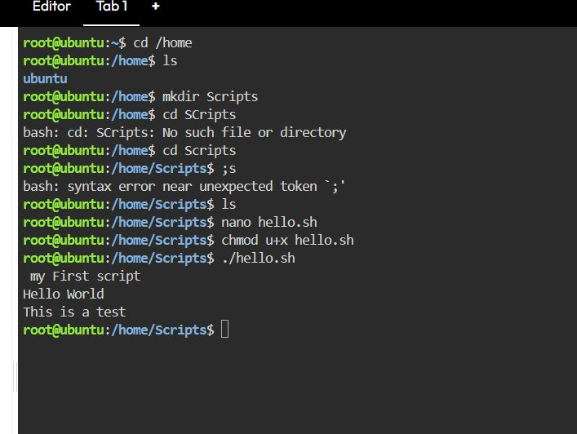
Key Concepts
› #!/bin/bash tells Linux to use Bash to run this file
› echo prints text to the terminal
› chmod +x makes the script executable before running

#02 — Variables
Teaches: Defining and using variables
Script — variable.sh
#!/bin/bash
name="Syed"
age=22
echo "My name is $name"
echo "I am $age years old"
Output
$ ./variable.sh
My name is Syed
I am 22 years old
Your Terminal Screenshot
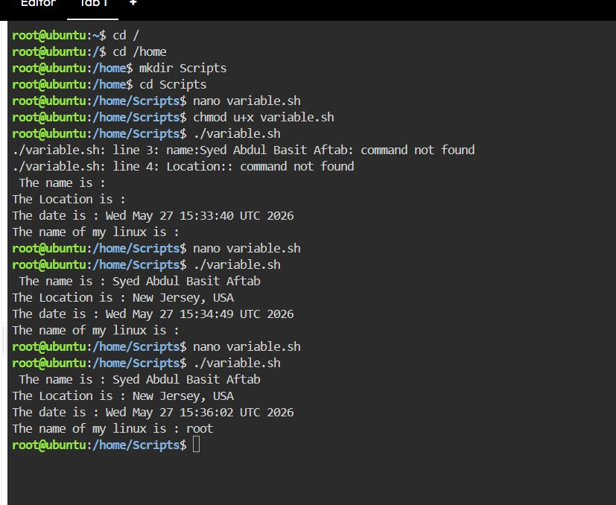
Key Concepts
› Variables store values — no spaces around =
› $name reads the variable value
› Wrap variables in quotes: "$name" to be safe

#03 — Arguments
Teaches: $1 $2 positional arguments
Script — arguments.sh
#!/bin/bash
echo "Hello $1"
echo "You are $2 years old"
Output
$ ./arguments.sh Syed 22
Hello Syed
You are 22 years old
Your Terminal Screenshot
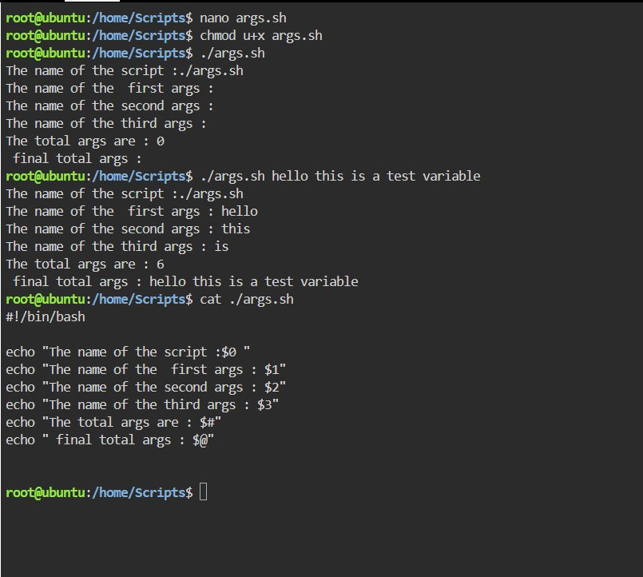
Key Concepts
› $1 = first argument typed after the script name
› $2 = second argument
› Bash sets these automatically — you do not define them

#04 — User Input
Teaches: read -p to get interactive input from user
Script — input.sh
#!/bin/bash
read -p "Enter your name: " name
read -p "Enter your age: " age
echo "Hello $name, you are $age years old"
Output
$ ./input.sh
Enter your name: Syed
Enter your age: 22
Hello Syed, you are 22 years old
Your Terminal Screenshot
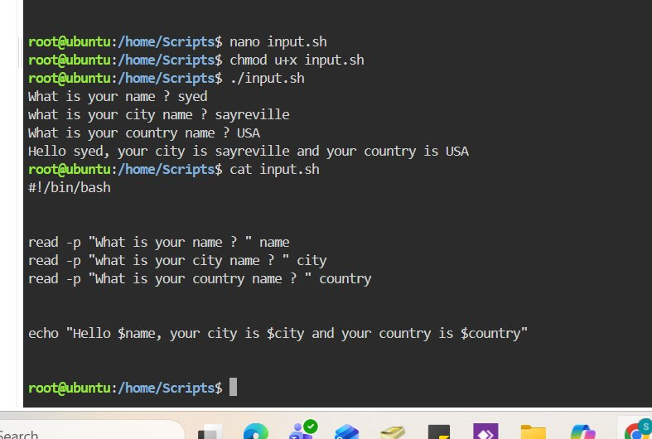
Key Concepts
› read -p shows a prompt and waits for the user to type
› The value they type gets stored in the variable
› Different from $1 — this asks interactively at runtime

#05 — Create File Script
Teaches: Creating files from a script using touch
Script — create-file.sh
#!/bin/bash
read -p "Enter file name: " filename
touch "$filename"
echo "File created: $filename"
Output
$ ./create-file.sh
Enter file name: test.txt
File created: test.txt
Your Terminal Screenshot
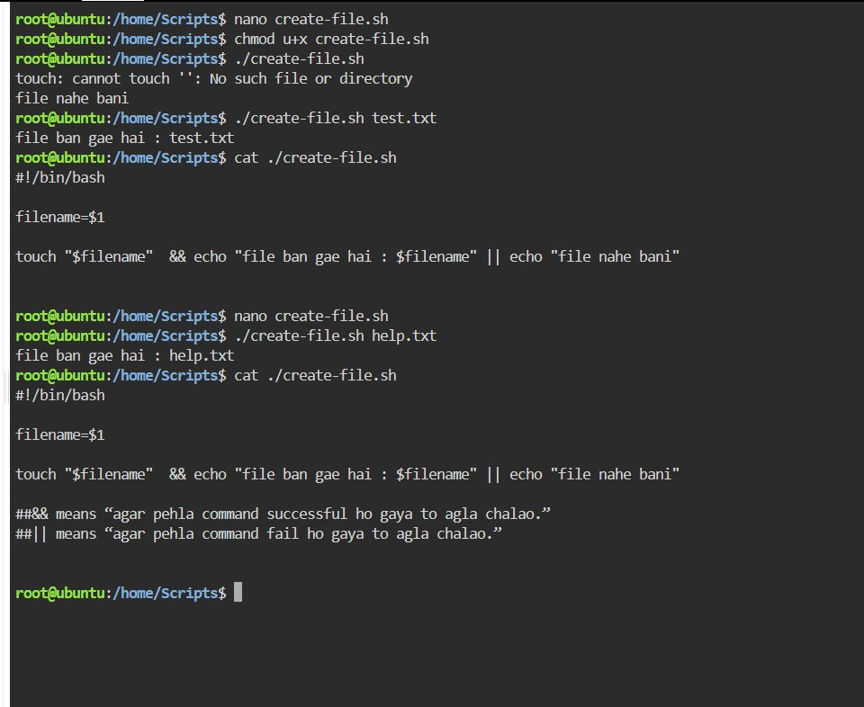
Key Concepts
› touch creates an empty file
› User input in $filename is passed directly to touch
› This is how scripts automate things you would normally do manually

#06 — Install Package Script
Teaches: apt-get install, automating software installation
Script — install.sh
#!/bin/bash
read -p "Enter package name: " package
echo "Installing $package..."
sudo apt-get install -y "$package"
echo "Done!"
Output
$ ./install.sh
Enter package name: curl
Installing curl...
...(apt output)...
Done!
Your Terminal Screenshot
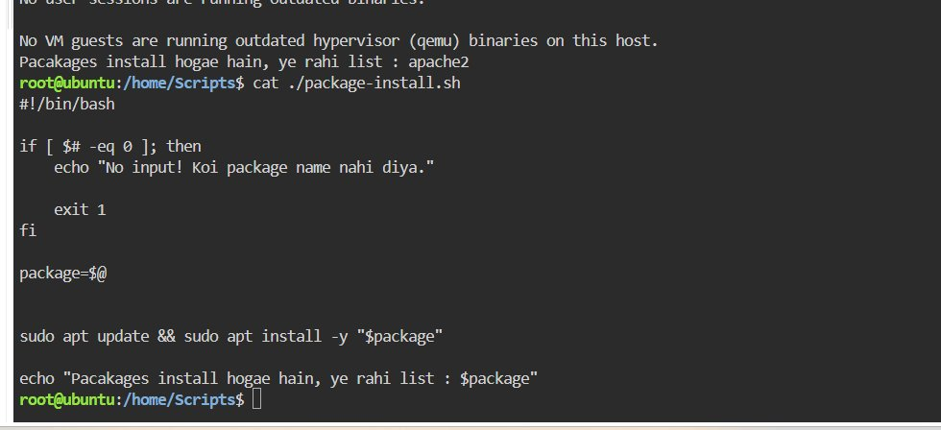
Key Concepts
› apt-get install installs software on Ubuntu
› -y auto-confirms all prompts so script does not pause
› sudo runs the command as root (needed for installing)

#07 — If-Else Script
Teaches: if / else / fi decision making
Script — if-else.sh
#!/bin/bash
read -p "Enter a number: " num
if [ $num -gt 10 ]
then
echo "Greater than 10"
else
echo "10 or less"
fi
Output
$ ./if-else.sh
Enter a number: 15
Greater than 10
Your Terminal Screenshot
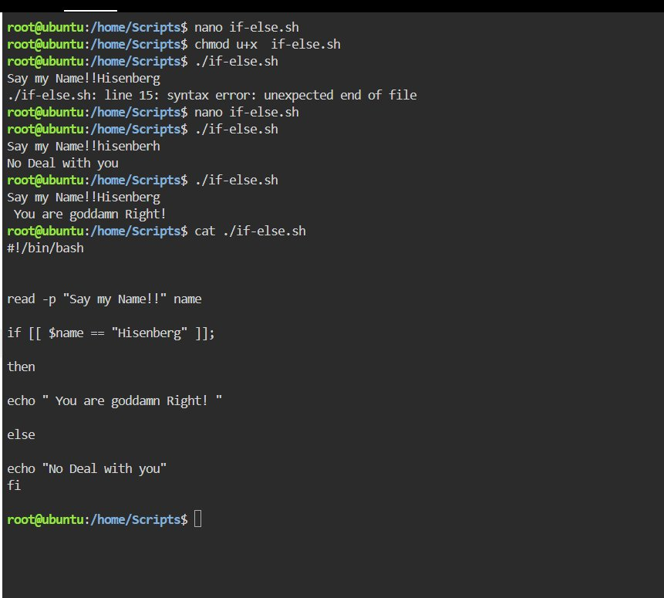
Key Concepts
› -gt means greater than
› -lt less than, -eq equal, -ne not equal, -le less or equal
› fi closes the if block — it is if backwards

#08 — Check File with -f flag
Teaches: -f flag to check if a file exists
Script — check-file.sh
#!/bin/bash
read -p "Enter file path: " filepath
if [ -f "$filepath" ]
then
echo "File exists"
else
echo "File does not exist"
fi
Output
$ ./check-file.sh
Enter file path: /etc/hosts
File exists
Your Terminal Screenshot
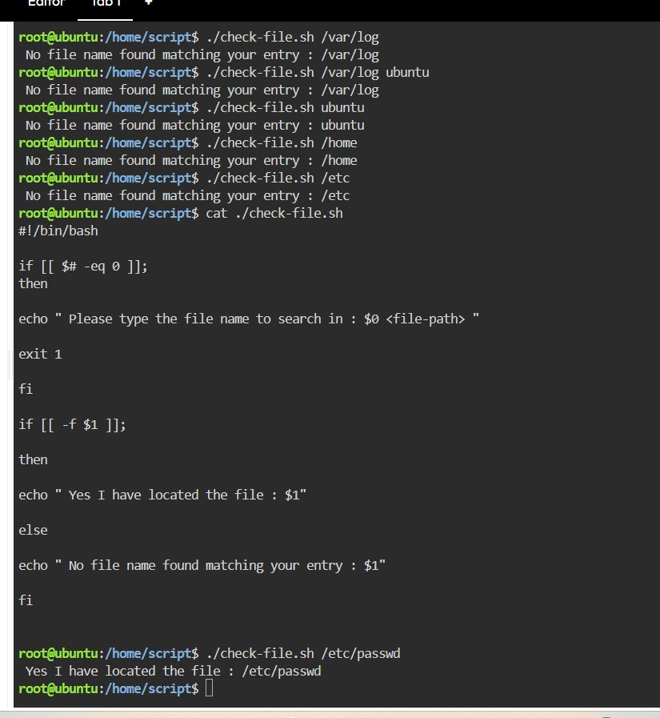
Key Concepts
› -f checks if path exists AND is a regular file
› -d checks if path is a directory
› -e checks if path exists as anything (file or directory)

#08A — Check File with -e flag (files and dirs)
Teaches: -e flag works for both files and directories
Script — check-file-e.sh
#!/bin/bash
read -p "Enter path: " path
if [ -e "$path" ]
then
echo "Path exists"
else
echo "Path does not exist"
fi
Output
$ ./check-file-e.sh
Enter path: /etc
Path exists
Your Terminal Screenshot
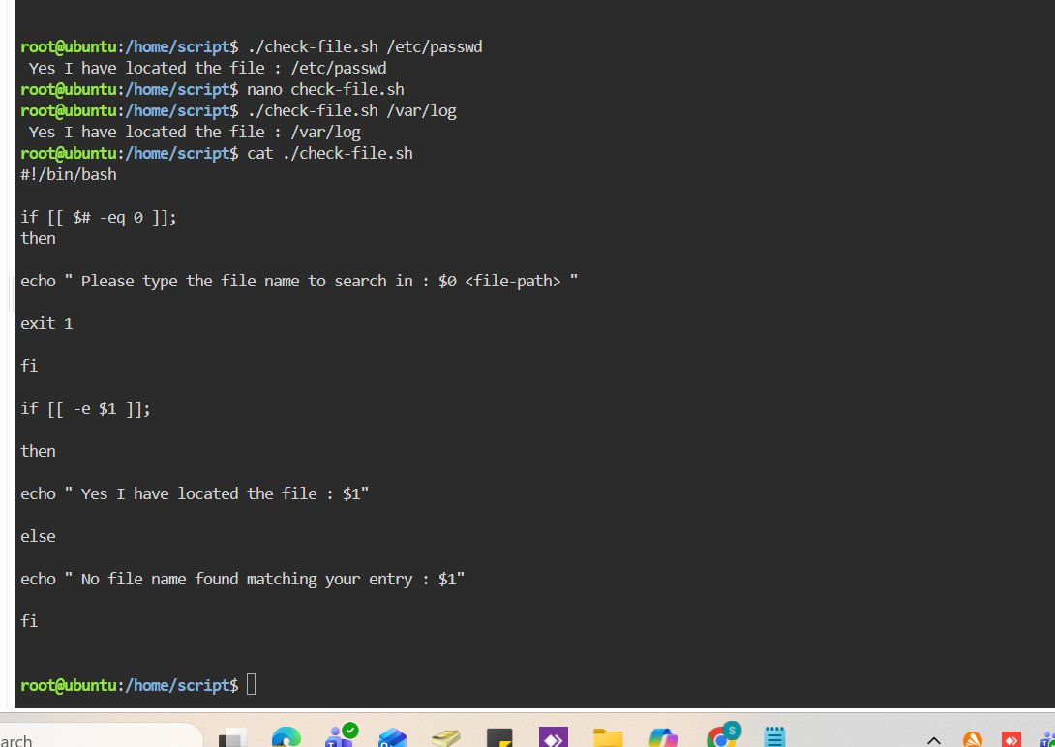
Key Concepts
› -e is more flexible than -f — works for files AND directories
› -f returns false for a directory even if it exists
› Use -e when you just want to know if anything exists at that path

#09 — Elif (else if)
Teaches: elif for multiple conditions
Script — elif.sh
#!/bin/bash
read -p "Enter a number: " num
if [ $num -gt 100 ]
then
echo "Big number"
elif [ $num -gt 50 ]
then
echo "Medium number"
else
echo "Small number"
fi
Output
$ ./elif.sh
Enter a number: 75
Medium number
Your Terminal Screenshot
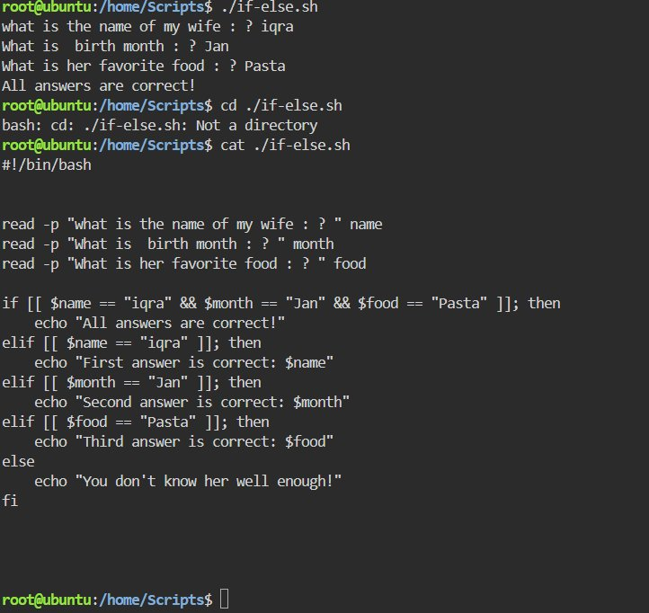
Key Concepts
› elif means else if — checked only when the first if is false
› You can chain as many elif as you need
› else at the end catches everything that did not match

#10 — For Loops
Teaches: Basic for loop over a list
Script — for-loops.sh
#!/bin/bash
for item in apple banana cherry
do
echo "Fruit: $item"
done
Output
Fruit: apple
Fruit: banana
Fruit: cherry
Your Terminal Screenshot
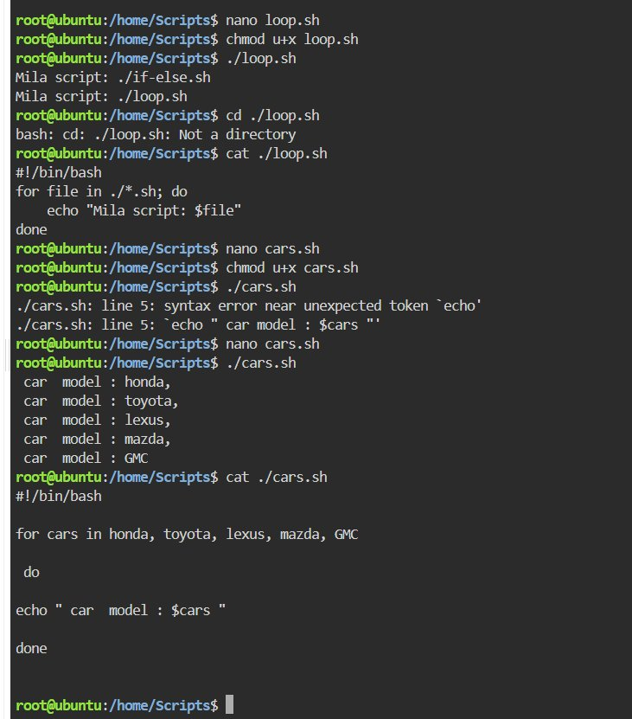
Key Concepts
› for x in list loops through each word one at a time
› $item holds the current word each round
› do opens the loop body, done closes it

#11 — Loop Counter
Teaches: For loop with number range, C-style loop
Script — loop-counter.sh
#!/bin/bash
# Method 1
for i in $(seq 1 5)
do
echo "Count: $i"
done

# Method 2 - C-style
for(( i=1; i<=5; i++ )); do
echo "Count: $i"
done
Output
Count: 1
Count: 2
Count: 3
Count: 4
Count: 5
Your Terminal Screenshot
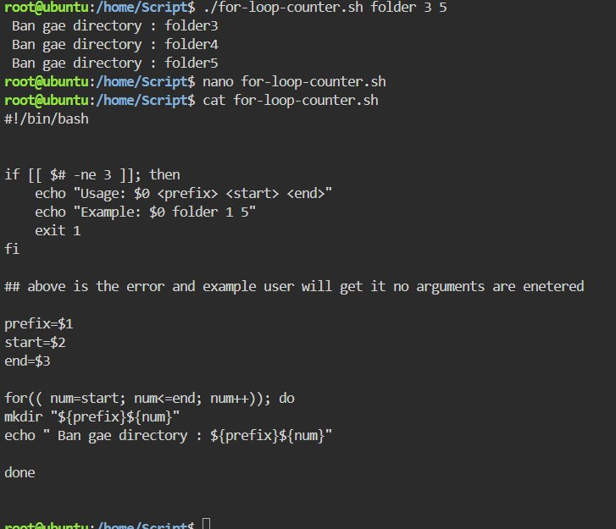
Key Concepts
› $(seq 1 5) generates numbers 1 through 5
› $( ) is command substitution — runs the command and uses its output
› C-style: for(( i=1; i<=5; i++ )) — no seq needed, just like other languages

#12 — While Loop — Even Numbers
Teaches: while loop, even number generation
Script — while-loop.sh
#!/bin/bash
num=0
while [[ $num -le 10 ]]; do
num=$(( num+2 ))
echo "Even number : $num"
done
Output
Even number : 2
Even number : 4
Even number : 6
Even number : 8
Even number : 10
Even number : 12
Your Terminal Screenshot
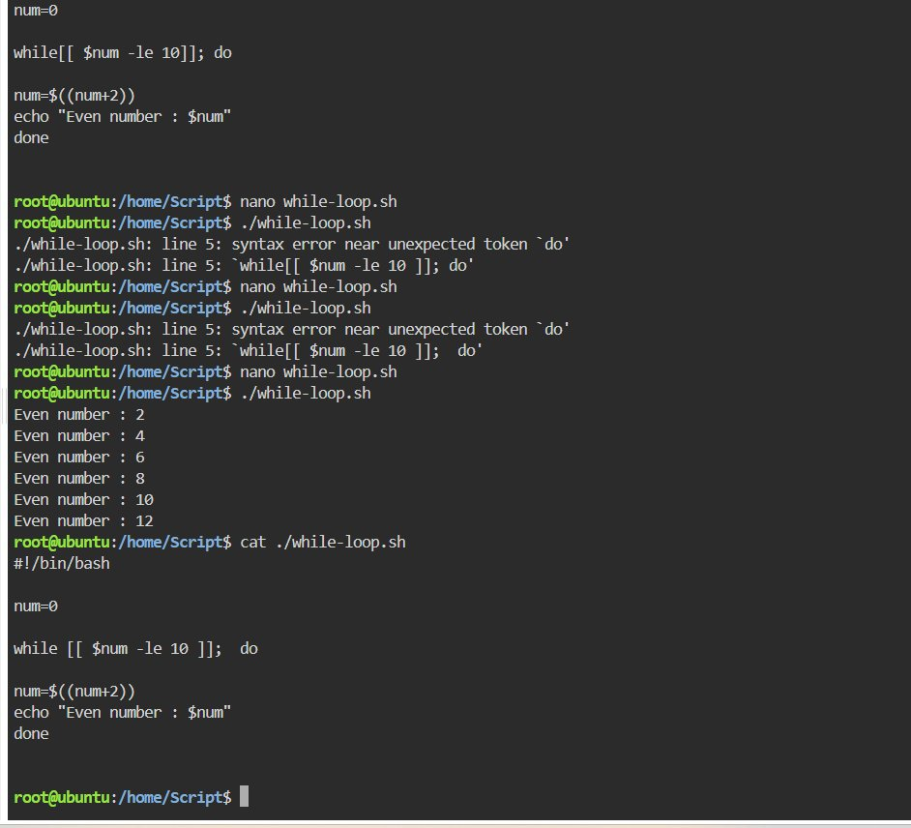
Key Concepts
› while [[ condition ]]; do ... done keeps looping while condition is true
› -le means less than or equal to
› Space required: while [[ works, while[[ breaks with syntax error

#13 — Functions
Teaches: Defining and calling basic functions
Script — functions.sh
#!/bin/bash
tea() {
echo " put some warm water"
echo " put some milk"
echo " drink it"
}
echo " tea making process"
tea
echo " finished"
Output
tea making process
put some warm water
put some milk
drink it
finished
Your Terminal Screenshot
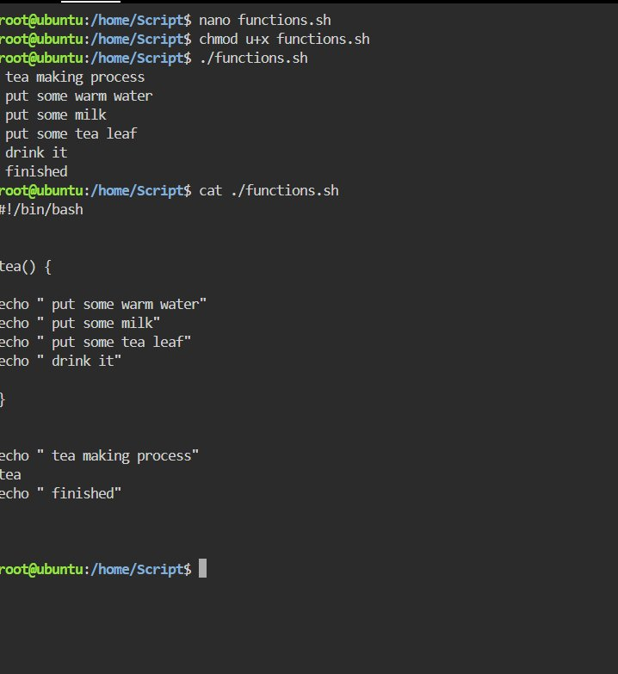
Key Concepts
› name() { ... } defines a function
› Just write tea to call it — no () needed when calling
› Code runs top to bottom, jumping into function when called

#14A — Function with Arguments
Teaches: Passing hardcoded arguments to functions
Script — func-w-args.sh
#!/bin/bash
greeting() {
echo " Hello sir $1"
}
greeting " Basit "
greeting " syed"
Output
Hello sir Basit
Hello sir syed
Your Terminal Screenshot
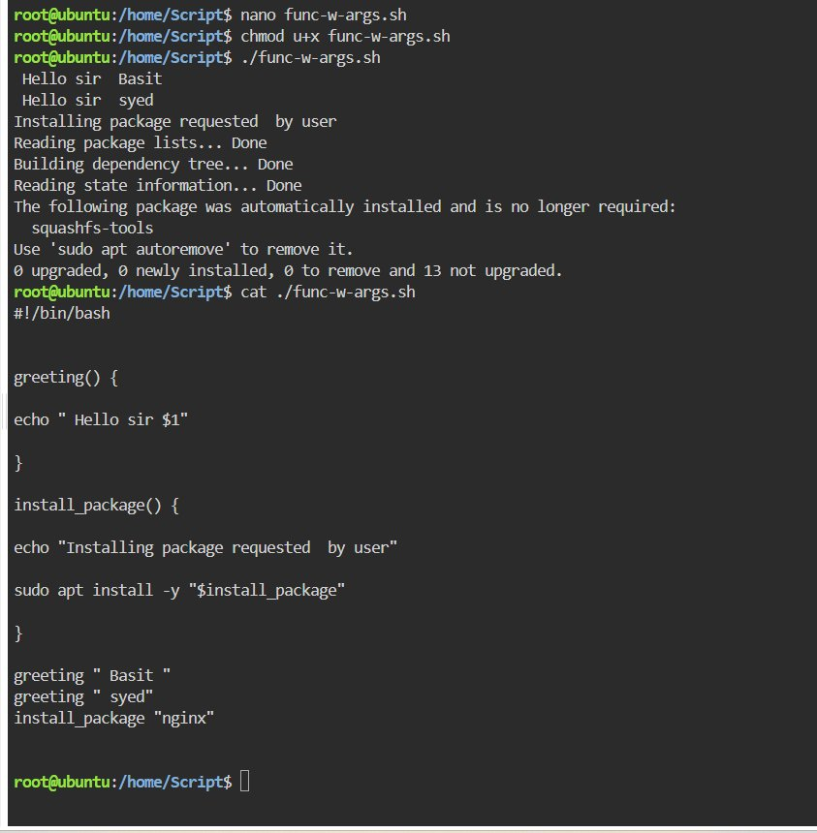
Key Concepts
› $1 inside the function = the argument passed when calling it
› greeting "Basit" makes $1 = Basit inside that function only
› Same function called multiple times with different arguments

#14B — Function with User Input
Teaches: Combining read user input with functions
Script — user-entry.sh
#!/bin/bash
greet() {
echo "Namaste $1 ji!"
}
read -p "Enter your name: " username
greet "$username"
Output
Enter your name: Syed
Namaste Syed ji!
Your Terminal Screenshot
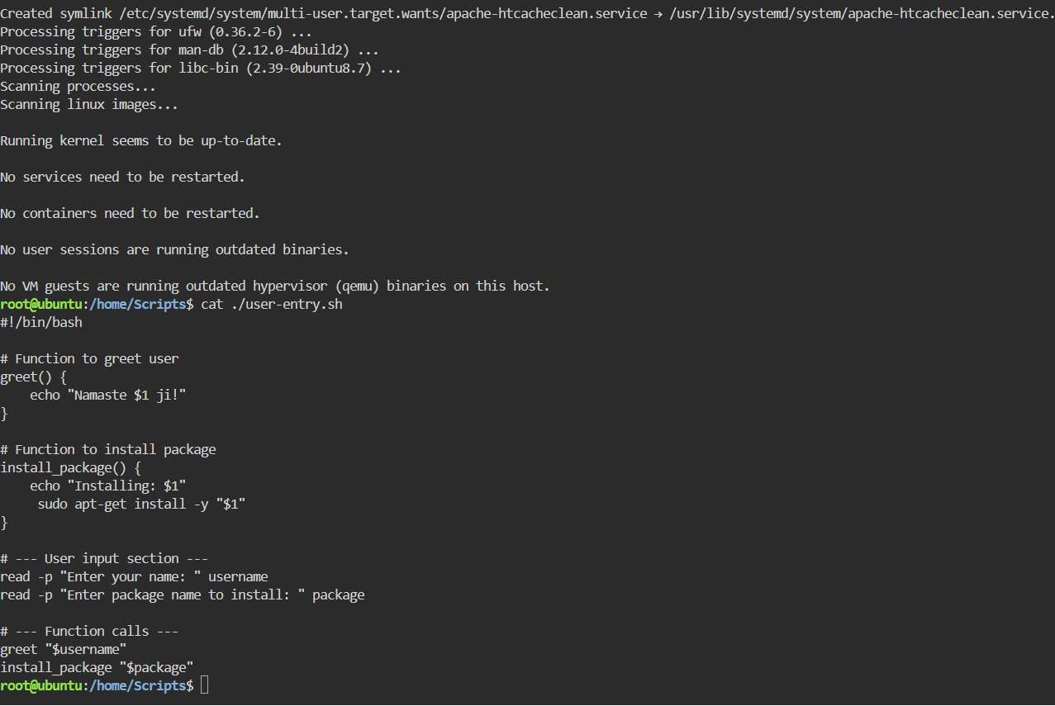
Key Concepts
› read collects input then passes it as $1 to the function
› Functions defined first, input collected after, calls at end
› Always quote variables: greet "$username" not greet $username

#15 — Reuse Function from Another Script
Teaches: source to load functions from another script
Script — function-reuse.sh
#!/bin/bash
source ./user-entry.sh
echo "------"
read -p " What is your name? " new_name
greet "$new_name"
Output
------
What is your name? Basit
Namaste Basit ji!
Your Terminal Screenshot
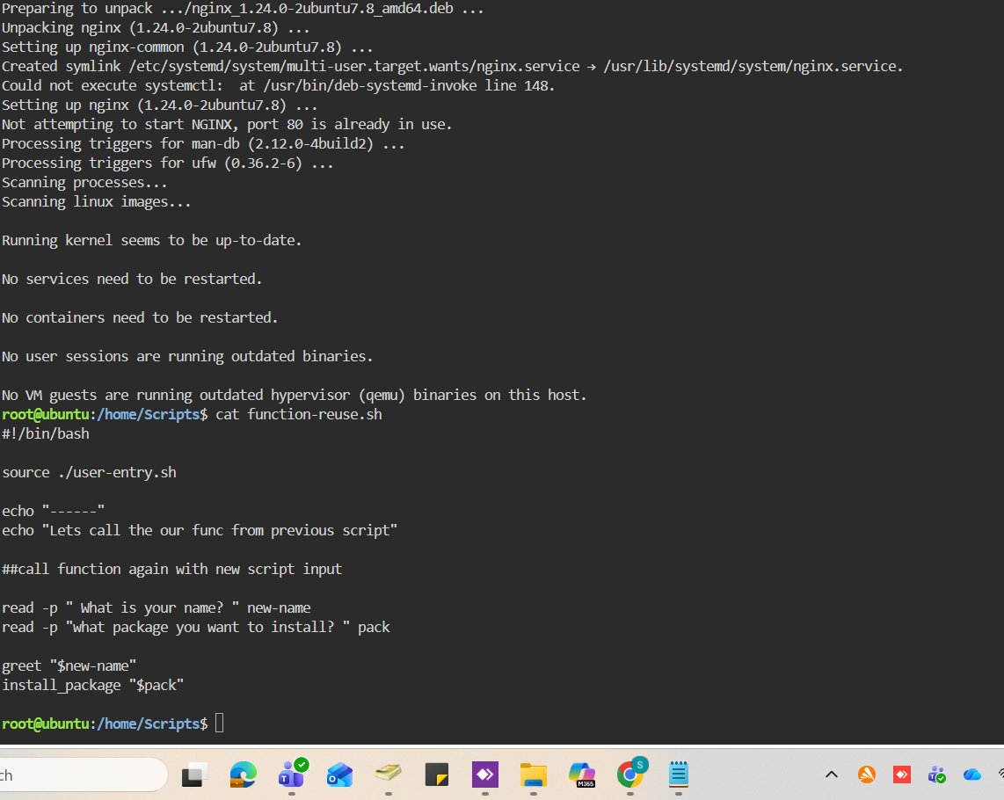
Key Concepts
› source ./script.sh loads all functions from another script
› You can call greet as if it were defined in the current file
› This is how you reuse code across scripts — no copy-pasting

#16 — if Inside a Function — Create User
Teaches: if inside a function, adduser, checking if user exists
Script — create-user.sh
#!/bin/bash
create_user() {
read -p "Enter name: " name
if id "$name" &>/dev/null; then
echo "Already exists"
exit 1
fi
sudo adduser "$name" && echo "Created!"
}
create_user
Output
Enter name: arfah
Already exists

Enter name: newuser
Created!
Your Terminal Screenshot
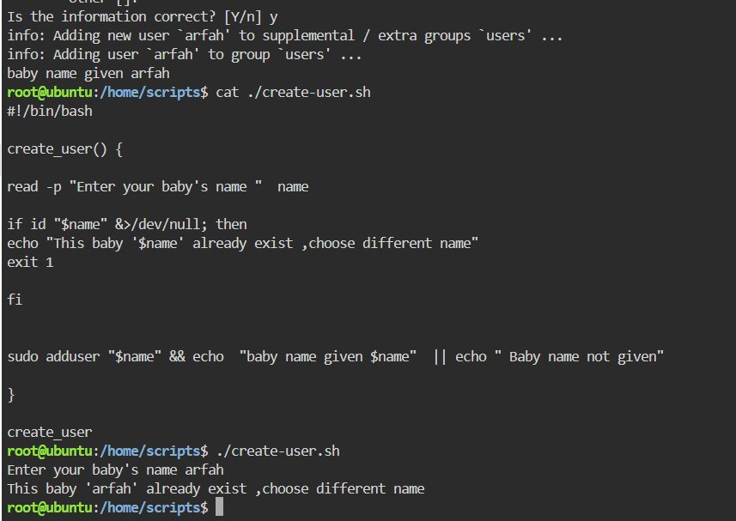
Key Concepts
› id "$name" checks if a Linux user already exists
› &>/dev/null silences both normal and error output
› && runs next only if previous succeeded, || runs only if it failed

#17A — Check Service Status
Teaches: systemctl is-active to check running services
Script — service.sh
#!/bin/bash
read -p "Enter service name: " service
if systemctl is-active --quiet "$service"; then
echo "Service is running"
else
echo "Service is NOT running"
fi
Output
Enter service name: ssh
Service is running

Enter service name: nginx
Service is NOT running
Your Terminal Screenshot
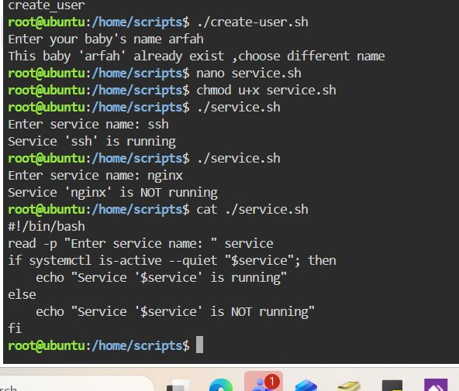
Key Concepts
› systemctl is-active checks if a service is currently running
› --quiet suppresses output — we only care about pass/fail exit code
› if reads exit code automatically — no [ ] brackets needed here

#17B — Check System Details with awk
Teaches: awk to parse and extract specific columns from output
Script — system-detail.sh
#!/bin/bash
check_memory() {
free -h | awk 'NR==2 {print "Available memory: " $7}'
}
check_storage() {
df -h / | awk 'NR==2 {print "Available disk: " $4}'
}
echo "=== System Details ==="
check_memory
check_storage
Output
=== System Details ===
Available memory: 1.4Gi
Available disk: 13G
Your Terminal Screenshot
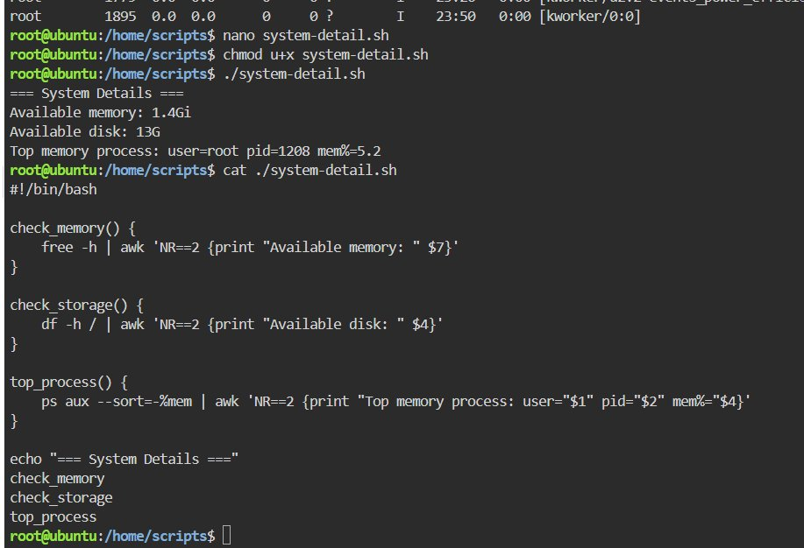
Key Concepts
› awk NR==2 means row number 2 of the command output
› $4, $7 are column numbers — counting whitespace-separated fields
› Pipe | sends output of one command into awk for clean data extraction

#18 — Error Handling — set -euo pipefail
Teaches: Production-grade Bash error handling with strict mode
Script — error-handle.sh
#!/bin/bash
set -euo pipefail
create_directory() {
mkdir "$1"
echo "$1 bana diya"
}
create_directory test_folder
echo "Aage badhte hain - sab theek hai"
Output
test_folder bana diya
Aage badhte hain - sab theek hai
Your Terminal Screenshot
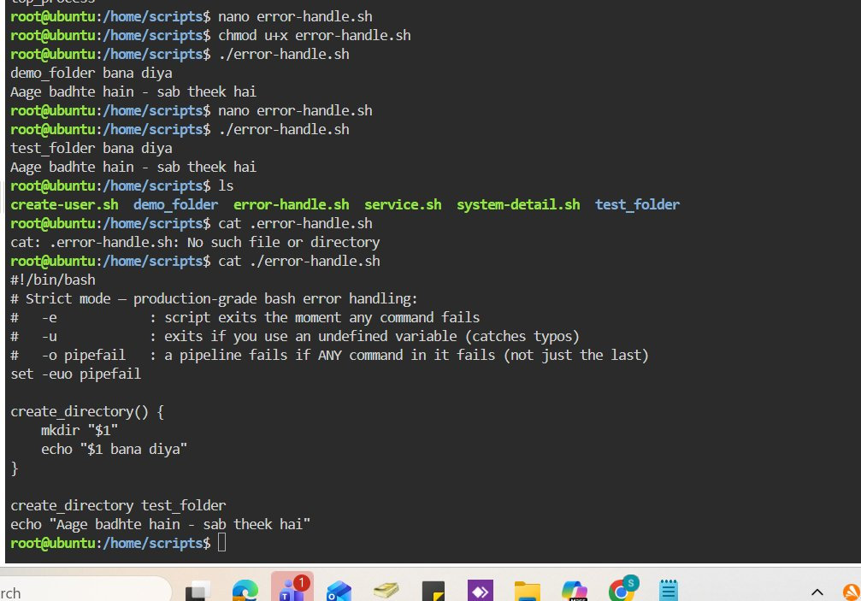
Key Concepts
› -e: stop immediately if any command fails
› -u: stop if undefined variable used — catches typos
› -o pipefail: if any part of a pipe fails, treat the whole line as failed

#19 — Backup Using Functions
Teaches: tar backup with timestamps, dirname/basename, default variable values
Script — backup.sh
#!/bin/bash
set -e
TIMESTAMP=$(date +%Y-%m-%d_%H-%M-%S)
BACKUP_DIR="${BACKUP_DIR:-$HOME/shell-backups}"
ARCHIVE="$BACKUP_DIR/backup_${TIMESTAMP}.tar.gz"
take_backup() {
tar -czf "$ARCHIVE" .
echo "Backup created: $ARCHIVE"
}
take_backup
Output
Backup created: /root/shell-backups/practice-scripts_2026-05-28_01-07-29.tar.gz
Your Terminal Screenshot
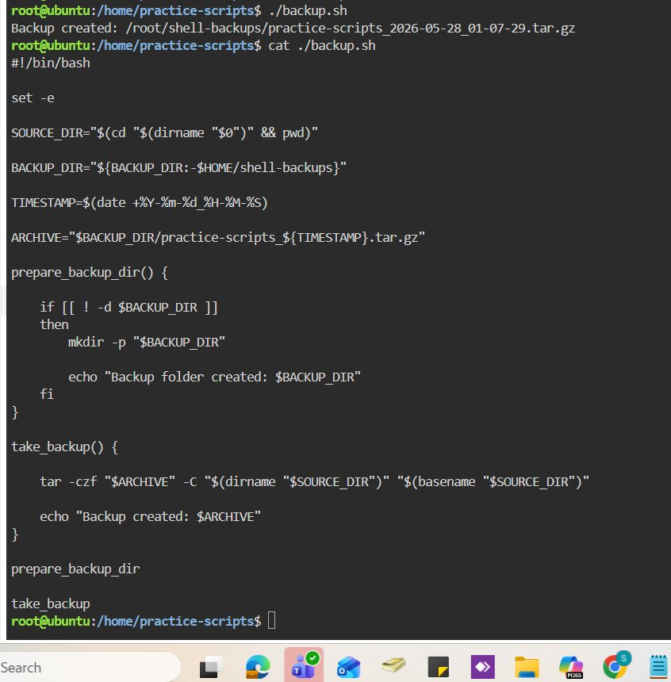
Key Concepts
› $(date +%Y-%m-%d_%H-%M-%S) creates a timestamp formatted for filenames
› tar -czf creates a compressed .tar.gz archive
› ${VAR:-default} uses VAR if set, otherwise falls back to the default

#20 — Cron Job — Auto Time Logger
Teaches: Cron scheduling, appending to log files automatically
Script — time-logger.sh
#!/bin/bash
echo "Cron ran at: $(date)" >> "/root/practice-scripts/time-log.txt"

# crontab entry:
# * * * * * /root/practice-scripts/time-logger.sh
Output
# time-log.txt grows every minute:
Cron ran at: Thu May 28 01:40:01 UTC 2026
Cron ran at: Thu May 28 01:41:01 UTC 2026
Your Terminal Screenshot
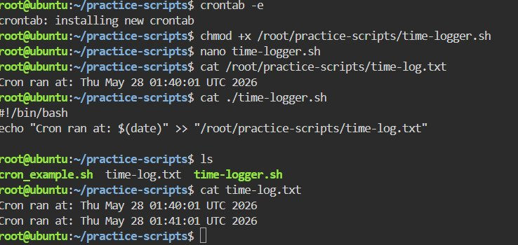
Key Concepts
› >> appends to file without overwriting — > would erase everything each time
› $(date) runs the date command and inserts output inline in the string
› crontab -e opens your cron schedule — * * * * * means every single minute

Built on Ubuntu 24 · Bash Scripting from Scratch 🔥

